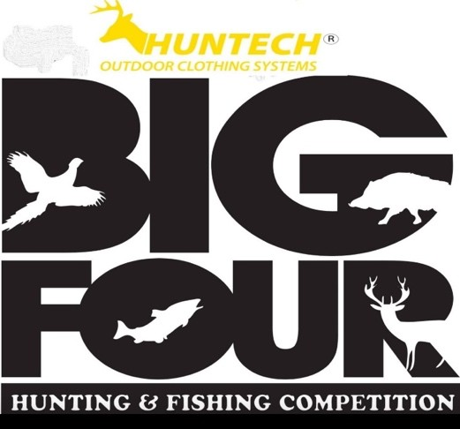

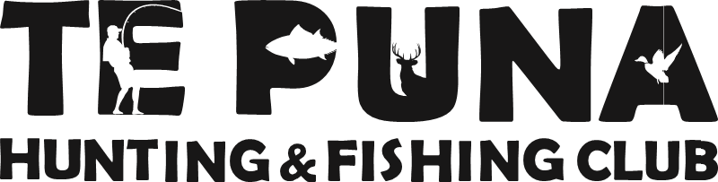
PROUDLY BROUGHT TO YOU BY

HUNTECH BIGFOUR - 2021 RULES

Four species only – Wild Stag, Wild Boar, Male ring-neck Pheasant and Trout
- The event will be run over four days. Hunting starts from 5.30am Tuesday 22nd through Wednesday 23rd Thursday 24TH until 11:59pm Friday 25TH with Saturday 26TH JUNE as weigh-in day and prize giving.

- Briefing will be held at 15D Top Shot Bar, Minden Road, Tauranga on Saturday 19th of June from 3pm. The rules will be read out at 4pm.
At least one member from every team is urged to attend briefing to collect starter packs and to hear any last minute rule changes.
- Entry fee is $400 for a team. Names of team members will be taken and no changes can be made after the cut-off date which is Wednesday 16th June 2021. No refunds will be made.

- One individual can only enter in a maximum of three (3) teams.

- Entrants must be able to provide photo identification that matches their name on the entry form. This could include trout licenses, pheasant game bird license, fire-arms license, drivers license. Any licenses where names do not match the name of entry and/or photo ID may be disqualified.

- Each team member will be given a limited edition (current year) ‘Huntech fleece tee’ in their team starter packs. This limited edition ‘Huntech fleece tee’ must be worn on the prize giving night by any contestant receiving a prize. Failure to wear their limited edition ‘Huntech fleece tee’ to the stage and/or on stage, will result in the prize being forfeited and redrawn as a spot prize.

- Contestants enter the competition at their own risk. The organisers and sponsors accept no responsibility for any loss, damage or personal injury incurred.

Weigh-in

One weigh-in only - Saturday 26th June from 10.30am to 3pm. Please note that no game shall be weighed after this time unless there is a queue and the contestants have reported in person to the weigh-in registration point prior to the cut off time of 3pm.
Each team can only weigh one of each species. The organisers will not permit a team to weigh more than one of each species to determine which one to enter.
  - Stags and boars to be completely gutted.
  - Boars to have nuts in, pizzels out.
  - Stags to have nuts out, pizzels out and throats removed.
  - If not done correctly contestants will be asked to do so before being accepted for weighing or charged $10 per animal by the club to correct.
  - Stags must be in antler.
  - Boars have no minimum weight.
  - Trout must be weighed whole (not gutted) and must be no less than the minimum length as specifies in the Fish & Game regulations for the lake or river where caught.
  - Pheasants must have tail feathers attached to be judged.
  - It is the competitor’s responsibility to remove any waste / entrails and animals from the premises.
  - Any game not wanted by any competitor or team may be donated to the club, if both parties agree, to be used for any purpose the club sees fit.

Four species only
  - Wild stag - any species
  - Wild boar
  - Male ring-neck Pheasant
  - Trout
Sows, hinds or hen pheasants will NOT be accepted.

Licences
Contestants must show all applicable licences in accordance with the taking of the species. e.g. trout licence, pheasant game bird licence, fire-arms licence, hunting permits. The organisers hold the right to refuse an animal or trout if known or thought to be captured in an unfair or illegal manner. To be valid, the trout and pheasants must be weighed in by the licence holder only. Licences must be valid at the time when the fish or animal was caught. Remember – a trout entered will only be accepted if the capture location declared by the entrant is in accordance with the entrants trout licence regulations. No exceptions.
- All game and fish must be presented in a fresh state. The independent weigh master or nominated committee members have the right to accept or decline any animal, bird or fish. The weigh masters decision is final and no correspondence will be entered into. It is strongly suggested trout are kept on ice or kept wet in the refrigerator. All other game needs to be kept cool and dry by the best practical means. All game must be in an unfrozen state and show no signs of having been frozen. Pheasants must be presented in a dry state. All game must be presented in an edible condition

- To qualify for the major team prizes, teams must enter ONE OF EACH species, i.e. Stag, Boar, Male Pheasant and Trout. The weigh-master reserves the right to disqualify any team. For all other prizes, a team is not required to enter all species.
NOTE - IF AN ANIMAL OR FISH IS DISQUALIFIED FOR ANY REASON, THEN THAT TEAM CANNOT ENTER ANOTHER IN ITS PLACE. YOU DO NOT GET A SECOND CHANCE.

TEAM AND INDIVIDUAL PRIZE SCORING

TEAM PRIZE SCORING
The points system for determining the winning teams is as follows:
A team getting closest to average weight stag, closest to average weight boar, closest to average quality score for the pheasant OR closest to average condition factor for the trout - will be allocated one point, with the second closest to average allocated two points, the third closest to average allocated three points, and so on. The teams with the lowest number of points are therefore the winners.
Example: Team A gets the closest to average Stag – gets 1 point; they also got the 18th closest to average boar (add 18 points), the 11th closest pheasant (add 11 points) and finally the 12th closest trout (add 12 points). Team A therefore have a total of 42 points.
If two or more teams have an equal number of points for a major team prize, the prize will be awarded to the team which weighed in their last particular species first.

INDIVIDUAL PRIZE SCORING
For the individual prize categories the 1ST 2ND and 3rd prizes for the stag and boar will be based on the heaviest weights.
The ‘best pheasant’ will be scored using a combination and calculation of weight, tail bars and average spur length – we refer to this calculation as the quality score.
The ‘best condition factor trout’ will be scored using the official Fish and Game calculation of [Weight in kg x 1000 x 3612.8] DIVIDED BY [length x length x length] (in cm).
The individual section is open to all teams who weigh in at least one species; i.e. if only one species is weighed by a team, the entrant of that team’s animal / fish has a chance at winning that particular section.
If two or more individuals weigh in the same weight animal or fish, the prize will be awarded to the individual whom weighed in their animal / fish first. Times will be recorded on each catch card at the time of weighing.
- No animals are to be shot from a helicopter.

- If boating, you are to comply with all safety regulations. Skippers launch at their own risk and discretion.

- All competitors are eligible to win spot prizes and raffled prizes, as long as they are there in person and wearing their 2021 limited edition ‘Huntech fleece tee’.

- All prizes are to be removed from the premises by competitor/s on the day. In some circumstances, prizes may be collected by midday Sunday 27th June at the latest.

- $10,000 prize draw is a team spot prize. Payment must be received by 11:59pm June 16th 2021 to be eligible. The team does not have to weigh in all species to be eligible, however all team members must be present in their current year ‘Huntech Big Four’ fleece tee. Prize will be drawn at random, under the supervision of a local authority.

Prize Categories

Major Team Prizes -
1st 2nd 3rd 4th 5th 6th 7th

Individual section
Trout – Best condition factor - 1^{st,} 2nd 3rd
Pheasant – Best pheasant quality score - 1^{st,} 2^{nd,} 3^{rd,} Stag - Heaviest - 1^{st,} 2^{nd,} 3rd
Boar - Heaviest - 1st, 2nd, 3rd
Stag - Best Douglas score - 1st only. NOTE: Any stag which is not a red stag will be Douglas scored using the official ‘red equivalent system’ by members of the Deer Stalkers Association.
Boar – Best hooks - 1st only. Douglas scored. NOTE: tusks must be intact and un-drawn to be eligible for scoring. Jaw must be attached.
Trout – Closest to average weight - 1st only. Pheasant - longest fighting spurs - 1st only.
Any and all contestants must be there in person to accept ANY prizes. Prizes will be re-drawn if not collected within five minutes.

Disqualification
If the weigh master or a committee member suspect any animal or fish presented is:
- not in a condition of expected quality (in terms of length of time since kill), or
- is frozen, or part frozen or appears to have been frozen and thawed, or
- shows signs of having been farmed, penned, caged or caught by illegal method, then the following protocol will be followed:
- the competitor will be given one opportunity to withdraw that animal;
- If that competitor refuses to withdraw the animal, then the weigh-master and judges will assess the animal and if unanimously agreed, will disqualify the entire team.

REMEMBER - YOU DO NOT GET A SECOND CHANCE.
Note: If you or your team do happen to get an unbelievably good animal, it would pay to bring evidence of when and where it was captured and photographic evidence if possible.

Aggressive Behaviour
  - Any person found to be causing a disturbance or disruption or acting in an aggressive manner e.g. fighting, will be escorted from the premises by security and refused re-entry.
  - At the discretion of the committee, the offender may have theirs and their team’s entries disqualified from the competition with no refund given
  - The individual may be banned from entering the competition again for 5 years.

- The committee reserve the right to refuse a team from entering this or future competitions.

Unlawful removal
Any person or persons found to have removed or suspected of removing animals or property from the competition area or surrounding area that they are not entitled too, will be referred to the New Zealand police for prosecution. No exceptions.

Contact
Any questions please email the club at tepunahuntfishclub@gmail.com or like us on Facebook and message us.

Disclaimer:

Any images taken of those participating in the event may be used to promote the event in the future.
Te Puna Hunting and Fishing Club, its members, or any of the event organisers are not responsible for the safety and wellbeing of entrants during this event.

All team members must be present to receive any major prize. Any issues arising regarding team members attendance must be declared on arrival and proof may be required. The final decision remains with the organising committee.

The competition organiser reserves the right to vary these rules up to briefing. Where any part of the rules are varied, the changes will be announced at the briefing.

